Chapter 6, Problem 22.

Obtain the equivalent capacitance of the circuit in Fig. 6.56.
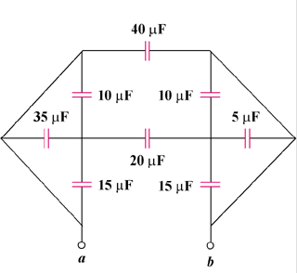

Figure 6.56
For Prob. 6.22.

